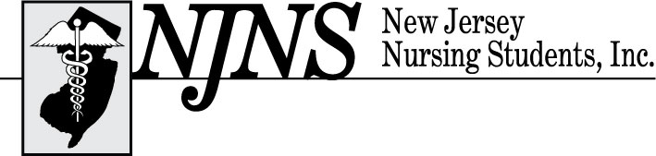
60th Annual Convention
Give the World the Best of You,
Not What’s Left of You

69th Annual Convention – Thursday and Friday, February 25 – 26, 2021
Offered Virtually

IMPACT Award
Due by *February 1st, 2021*

New Jersey Nursing Students, Inc. (NJNS) members have the opportunity to recognize an individual who has had an impact on their nursing education and/or career choice. This individual may be a dean, director, faculty member, mentor, or relative who demonstrates support to nursing students.

Purpose:
NJNS has created this award to honor individuals who demonstrate educating and/or supporting a student’s professional development.

Awards:
Three awards will be presented based on the essays submitted. Decisions of the committee will be final. The award will be given during the virtual Convention. The recipient must be present to receive the award.

Criteria:
- The nominee must have made a substantial impact on and supported the student during nursing school.
- An essay describing the activities involved with the student must be submitted by February 1st, 2021.

Application Process:
- The candidate must be nominated by a nursing student, who is a current National Student Nurses’ Association (NSNA) member.
- NJNS must receive a completed application by the official deadline. (NO LATE APPLICATIONS WILL BE ACCEPTED).
- Applications will be reviewed by the IMPACT Award Committee for eligibility.
- The student may nominate only one individual.
- Complimentary lunch will be provided for the award recipient only.
- Recipients will be notified within February.

Send completed application and essay to Regina Adams, MSN, RN, CNOR
at staff@njnsinc.org.
IMPACT Award Nomination Form
Deadline: *February 1st, 2021*

Award (check one): _ Dean/Director _Faculty Member _Mentor _Other

Nominee: (print name clearly as you want it to appear on award) ***

Name and credentials: ________________________________________________________

Email address: ______________________________________________________________

If other, indicate relationship ___________________________________________________
Attach a typed, double spaced essay (maximum of 500 words) describing the impact that the nominee has had on your career choice or nursing education. Include the reasons why you believe that the nominee meets the criteria for this award.

Student Information:

Name: ____________________________________________________________________

School: _________________________________ City: _____________________________

Phone: _________________________________ Email: ____________________________

NSNA Membership Number: _________________________________________________

Student’s Signature: _______________________________________ Date: ____________

Information submitted on the application will be used for the awards. NJNS is not responsible for incorrect names or credentials printed on the awards.

If you have any questions, you may contact Regina Adams, MSN, RN, CNOR via email at staff@njnsinc.org or by phone (609 )883-5335.

